**Remote Desktop for OSX - 2018**

1. Open the Apple Store - In the search tab type **Microsoft Remote Desktop 10**
2. Install the Application

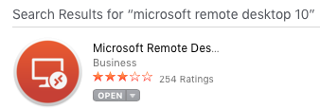

1. Open the Application and Click on **Add Desktop**
2. Enter your PC Name – To find your PC Name see document “Locate Office Computer Hostname.docx” After PC Name is entered please add **.circ6.dcn** (see attached)

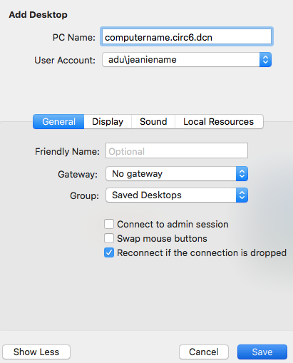

1. Select **User Account** and Enter **adu/jeanieusername** (see attached) **Leave Password Blank** – **Click Save.**

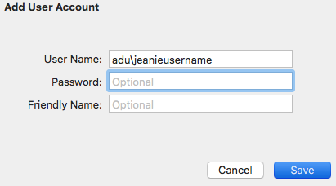

1. Make sure your **PC Name** is shown and your **User Account** is selected – Click **Save.**

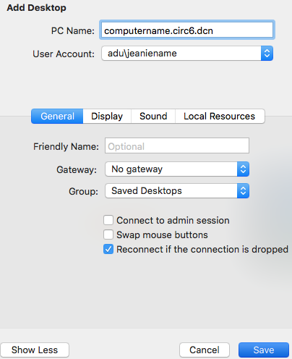

1. **Double Click** on the **PC name** to launch Remote Desktop Session to Office PC.

